**Curriculum Vitae**

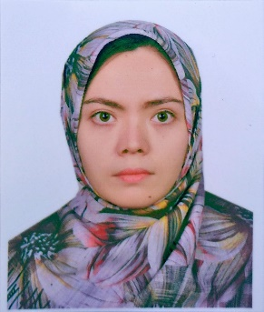

**Masoma Rezaie. Herat, Afghanistan**

Masoma.poya1995@gmail.com

# +93789449640

### **Professional Profile**

 a passionate network technician currently diving into the world of **web design** and **graphic design**. After years of working in different sections, I discovered a love for creativity, visual expression, and user experience. This portfolio marks a new chapter in my life — a fresh beginning where I blend technical skills with artistic design.

Through my personal brand, **Wixdora.Studio**, I’m building not only projects — but also a dream: to work remotely, grow independently, and someday create designs that speak globally. I’m still learning, but every line of code and every pixel I place is a step closer to that goal. Thank you for being part of this journey.

**Sales Assistant**

Fushanj Telecom( ISP Private Company)

Jan 2024 up to now

* Making appointments, ports
* Reporting Troubleshooting
* Call center operations
* Selling internet packages
* Network Technician

# Teacher

Multiple organizations

2015 – 2023

• Teaching English and school subjects in private organizations.

# Doctor assistant

Private hospital

January 2018 to December 2018

* Typing patient reports and printing
* Organizing patients

# Education

Student of 6th semester of Sociology Field

March 2019 to August 2022

Computer Technology (Network)

CTI institute - Kabul, Afghanistan

2015

High school

Nesvan school

2013

# Skills

* Project management
* Time Management: Strong time management skills, able to meet deadlines and manage multiple research projects.
* Teamwork Skills: Experience in collaborative projects and effective teamwork with peers and professors.
* Effective Communication: Ability to communicate ideas clearly and present research findings in academic settings.
* Technical: MS office, SQL server, Internet, Linux OS, typing.
* Graphic: Photoshop. Illustrator
* Ability to work under stress
* Fast leaner who keen to learn guidelines and procedures
* Applicable to job work harmoniously with colleagues from various culture

# Languages

|  |  |  |  |  |  |
| --- | --- | --- | --- | --- | --- |
| Mother tongue(s) | Persian | | | | |
|  |  | | | | |
| Other language(s) | UNDERSTANDING | | SPEAKING | | WRITING |
| Listening | Reading | Spoken interaction | Spoken production |  |
| English | C2 | C2 | C1 | C2 | C2 |
| Dari | C2 | C2 | C2 | C2 | C2 |
| Pashto | B1 | B1 | B1 | B1 | B1 |

# Certificates

* English – upper intermate and EF SET (online)
* Teacher training
* Advance Level (C2) From Q-skills
* ICDL programs
* Advance Remote Networking Online Course from Germany in 2024-2025
* Online Graphic Design course at CTI( code to inspire)in 2024-2025

# References

Abdullah Kiyanush

Technician Employee of Fushanj Telecom

0093 775842089

Abdul Wahab Yusofi

Fushanj Telecom finance manager

0093 797434030

Mr. Alkozay

General manager of Fushanj Telecom

0093 796090035